**GIT&HUB-2**

1. Install git.

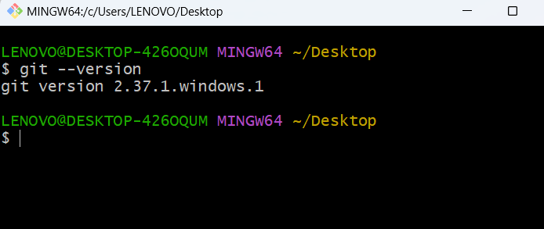

1. Create a repo in github with README.md and .ignore file.
   1. Create repo in github

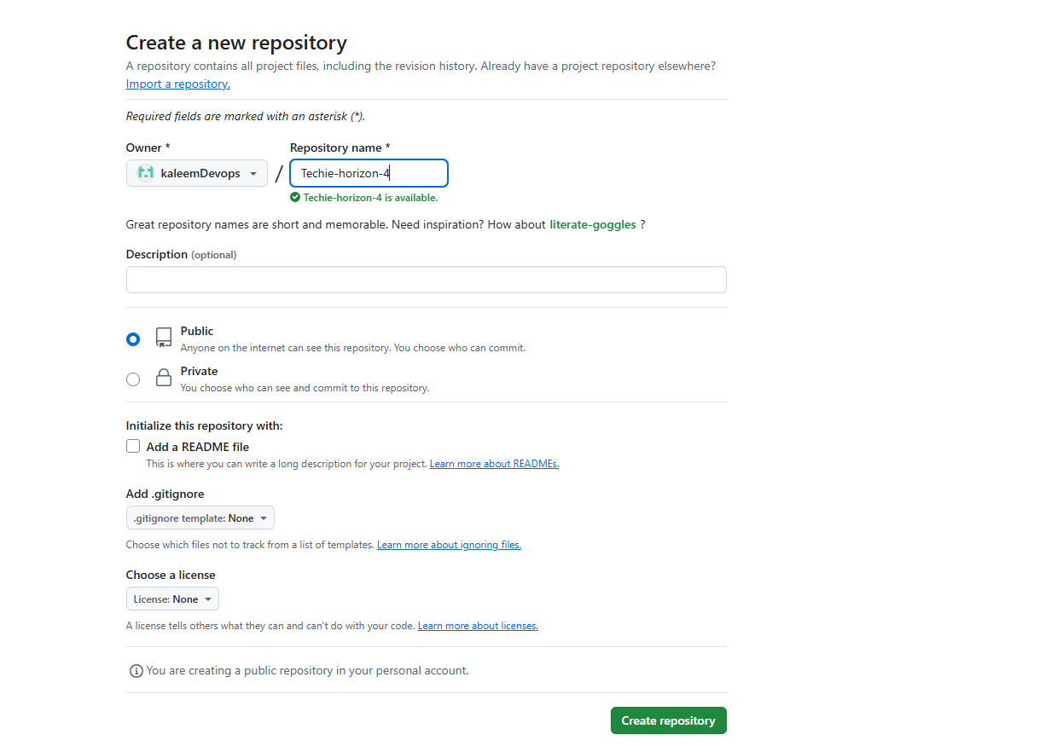

* 1. README.md

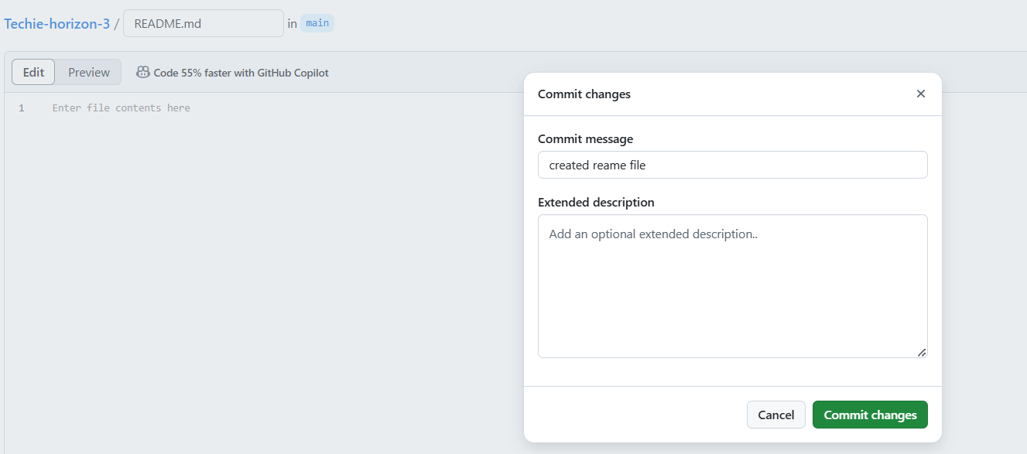

* 1. .gitignore file

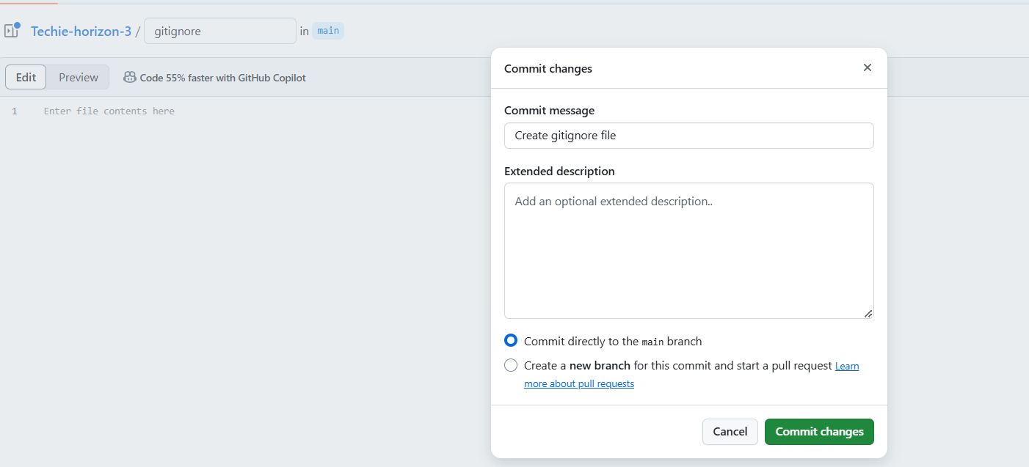

1. Clone the created repo to local.

Got to github copy ssh link and past in cli

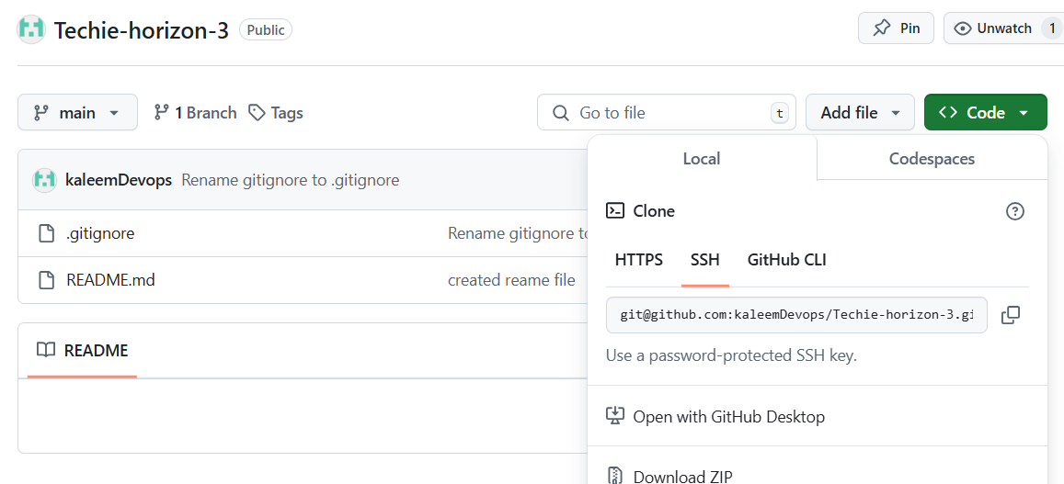

git clone git@github.com:kaleemDevops/Techie-horizon-3.git

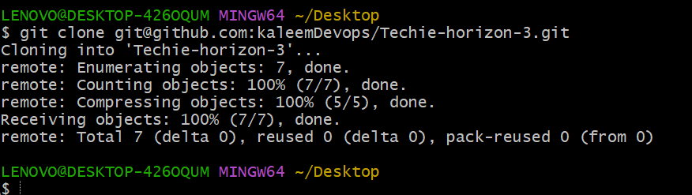

1. Create two files in local repo.

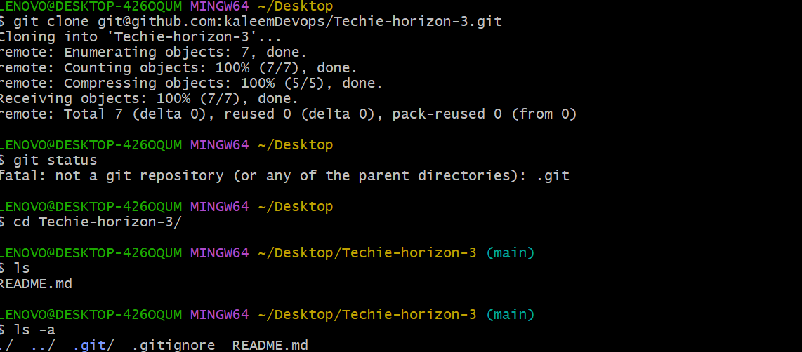



1. Commit two files and push to central Repository.

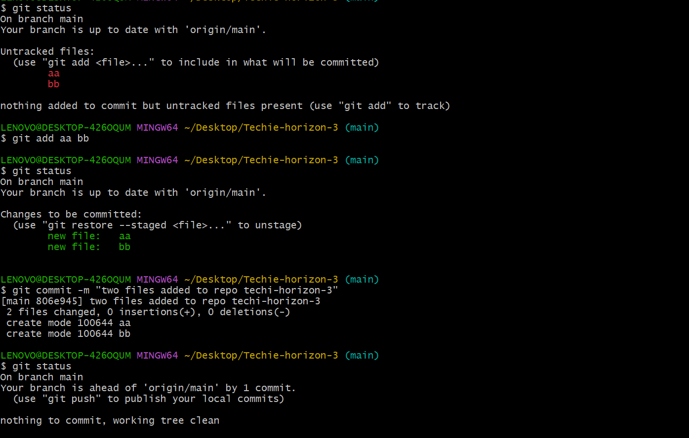

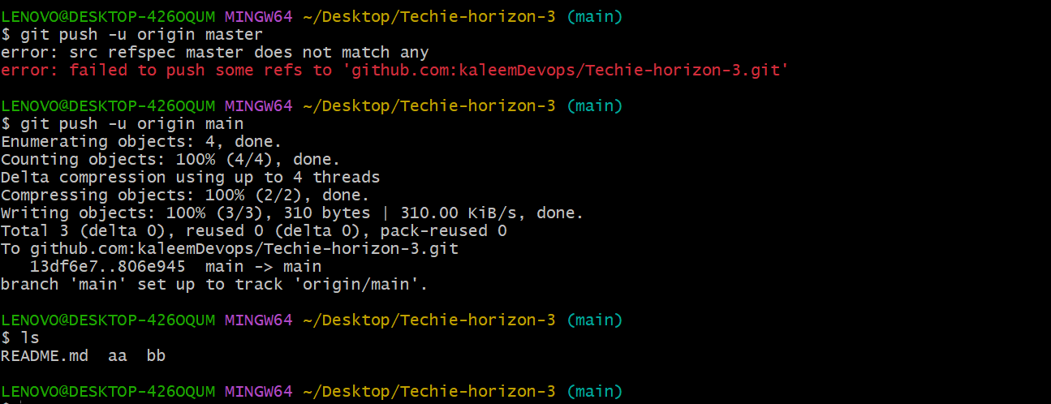

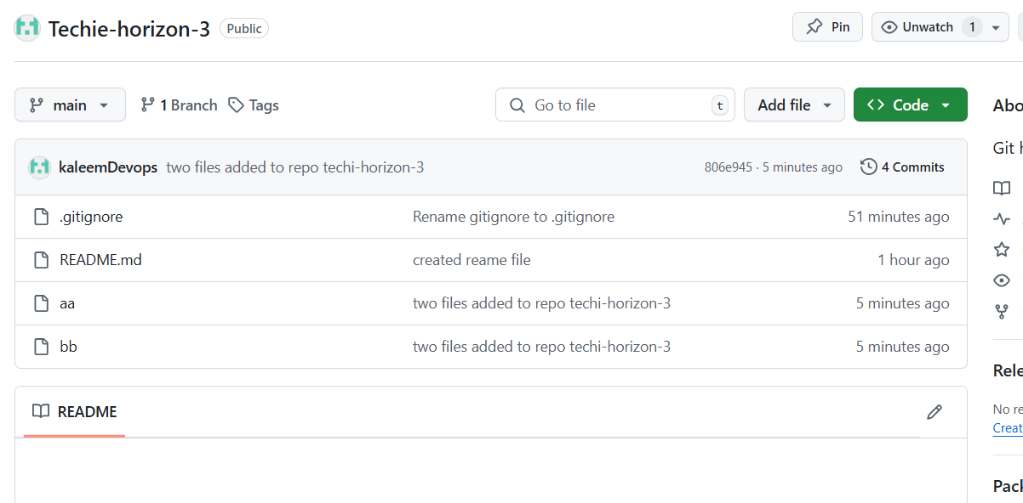

1. Create a branch in local and create a sample file and push to central.

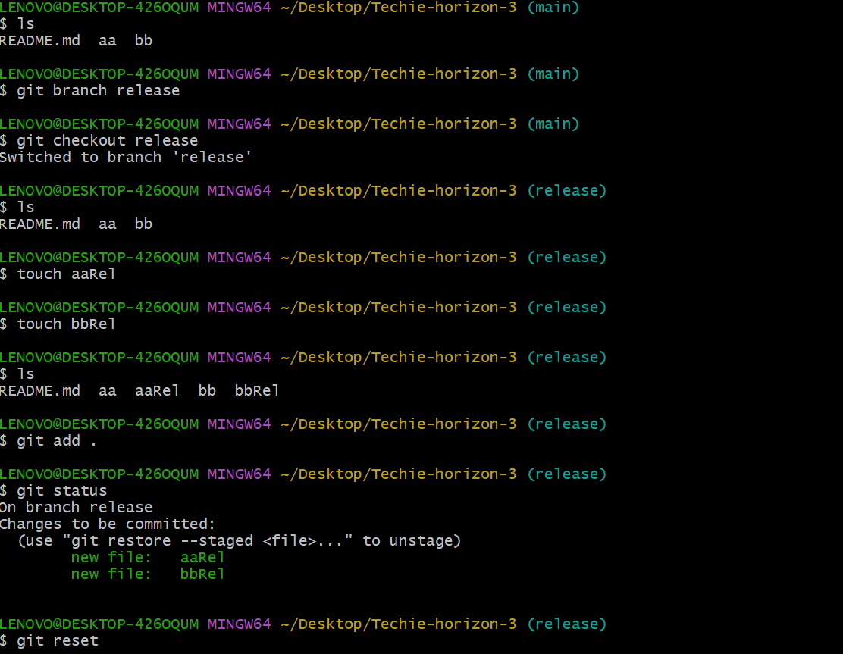

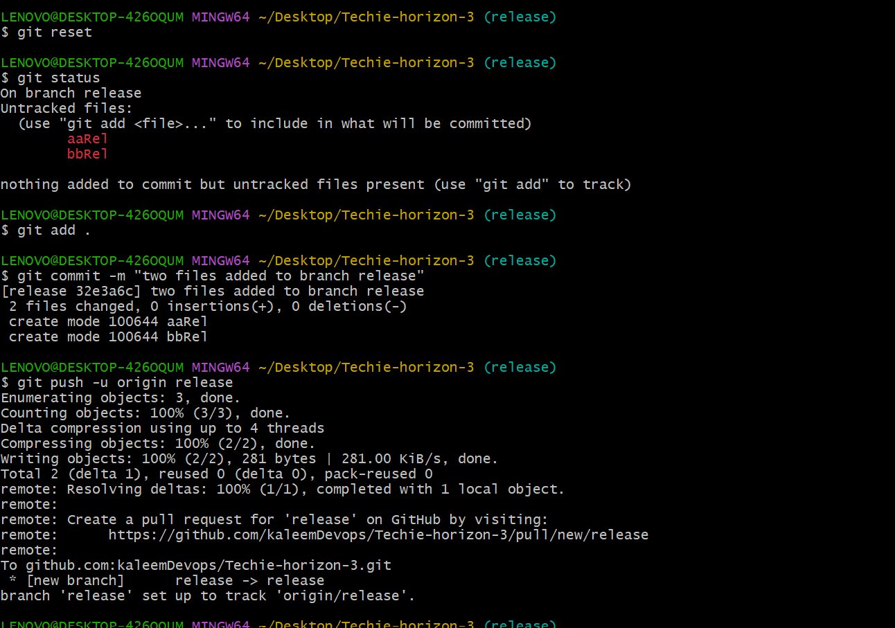

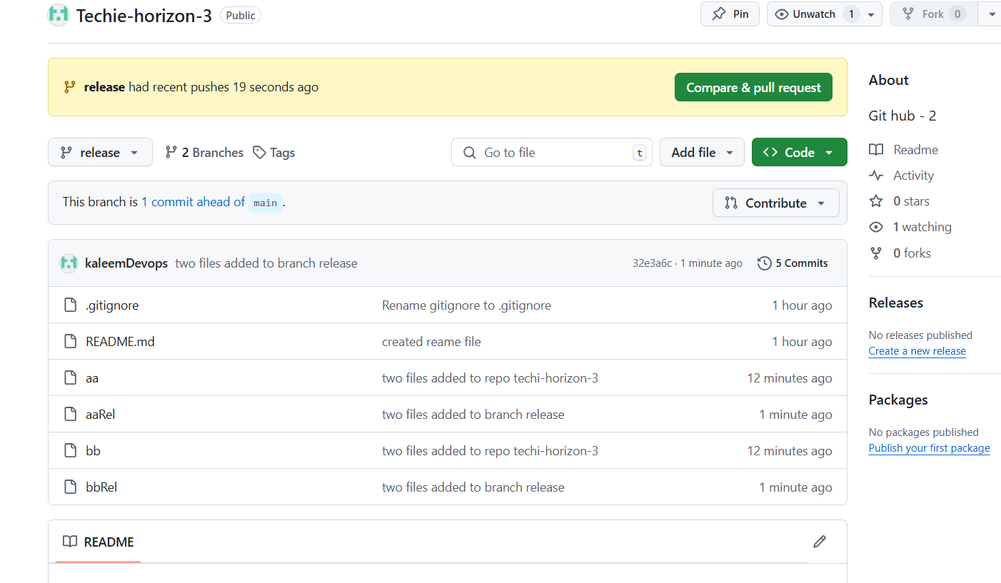

1. Create a branch in github and clone that to local.

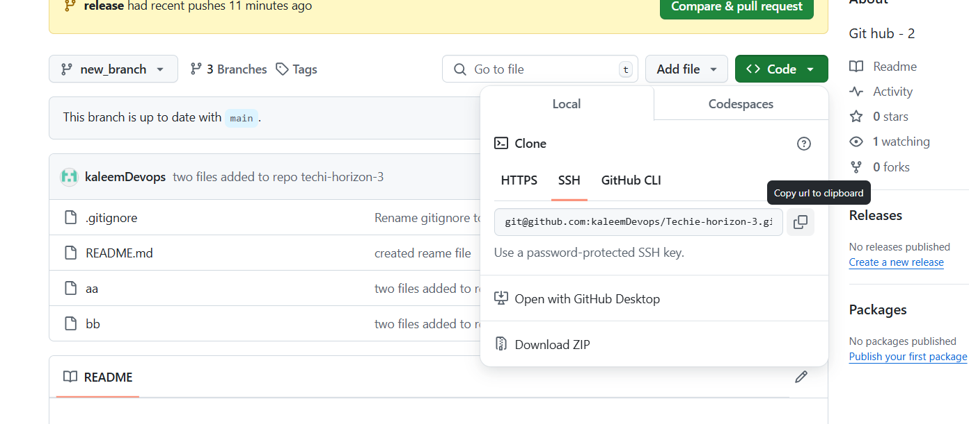

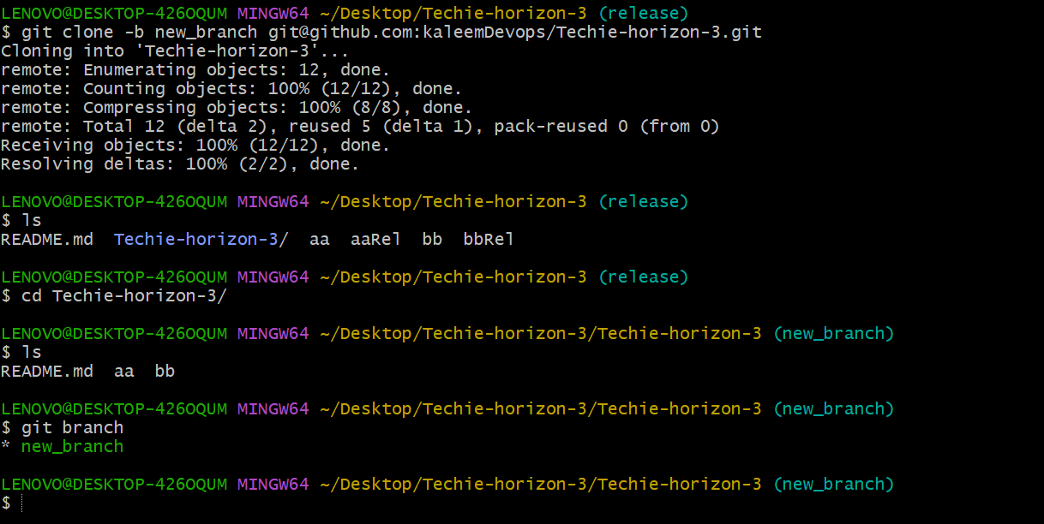

1. Merge the created branch with master in git local.

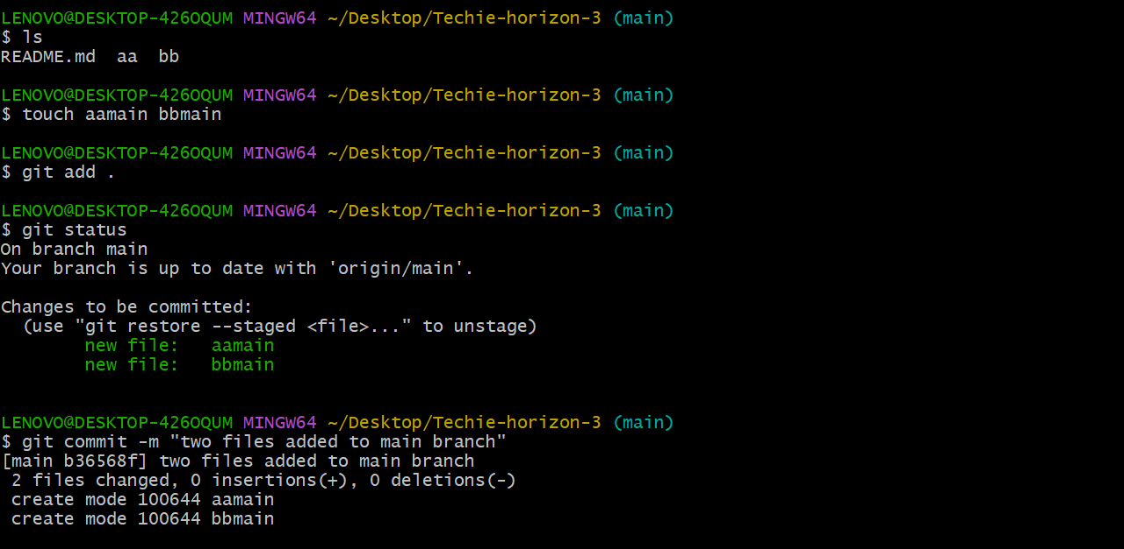

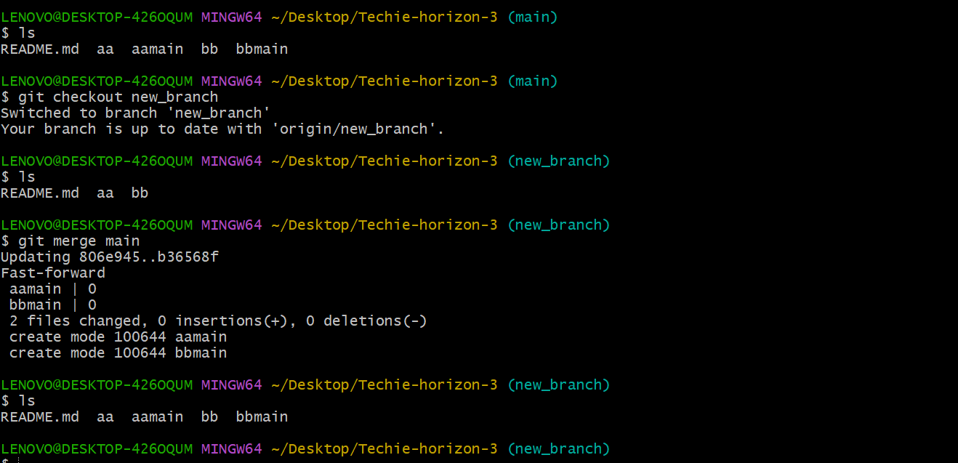

1. Merge the created branch with master in github by sending a pull request.

Create new file in child branch then it will ask for compare and pull request

* Main branch

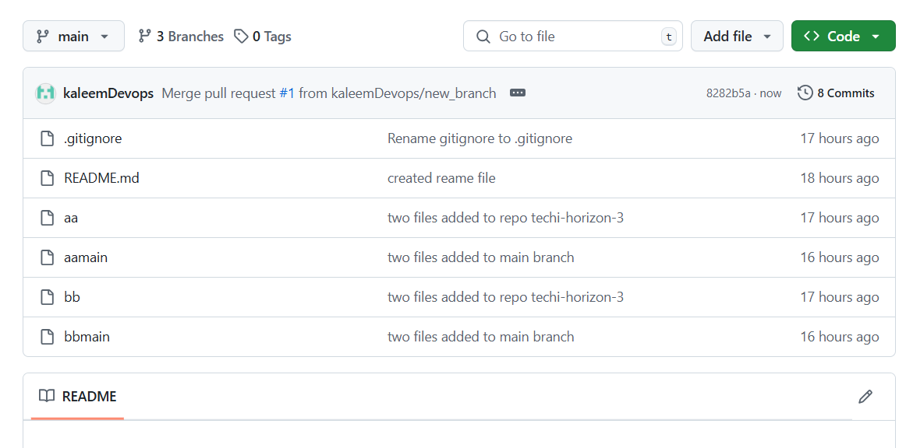

If child branch has some difference, it will show compare and pull request

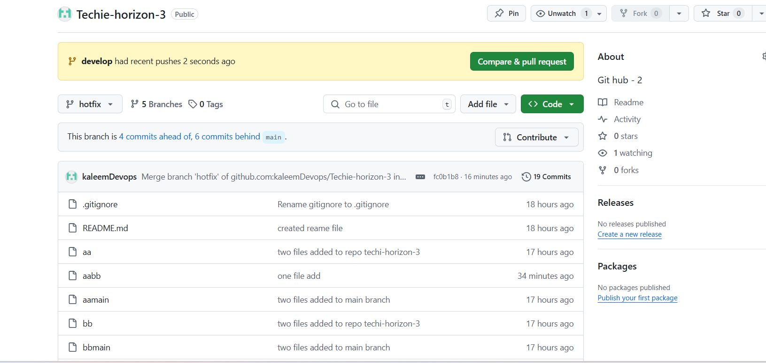

1. create a file in local and send that to branch in github.

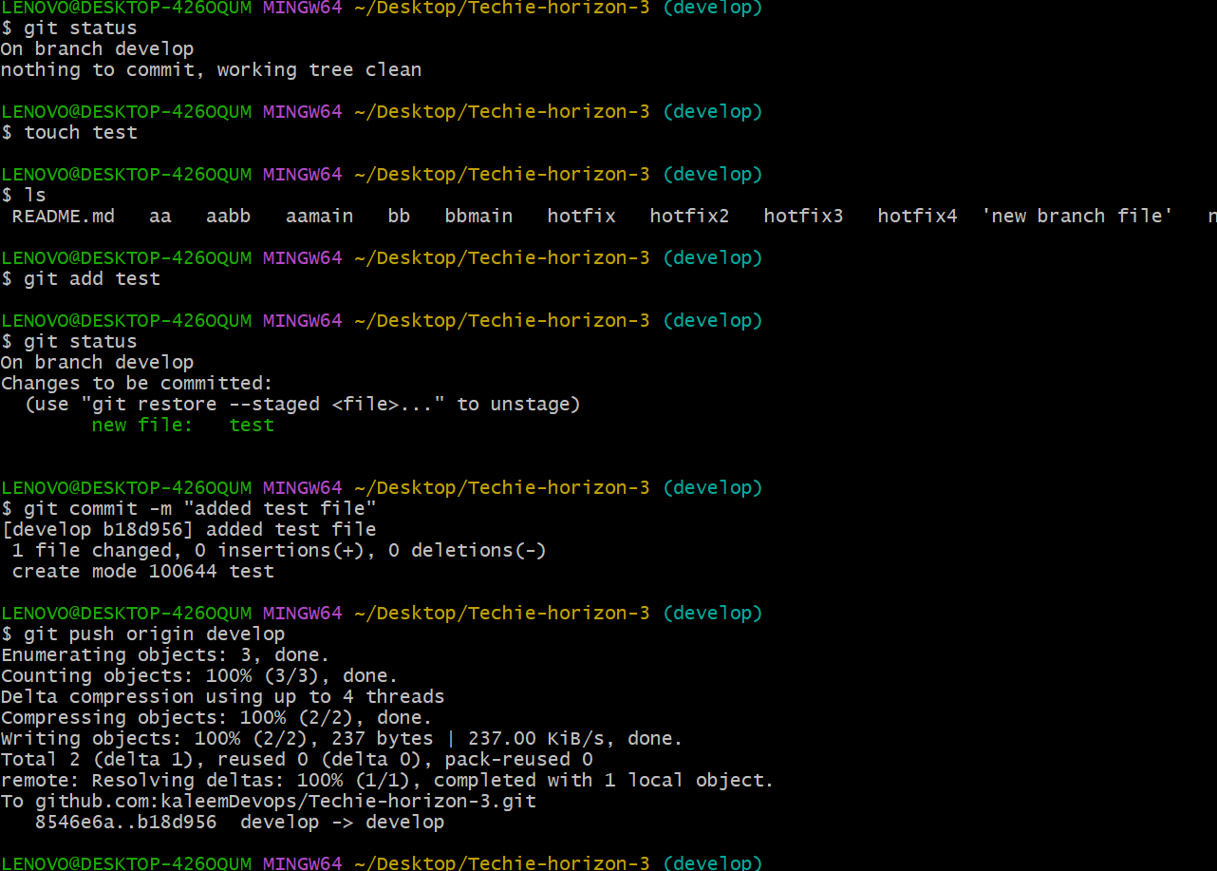

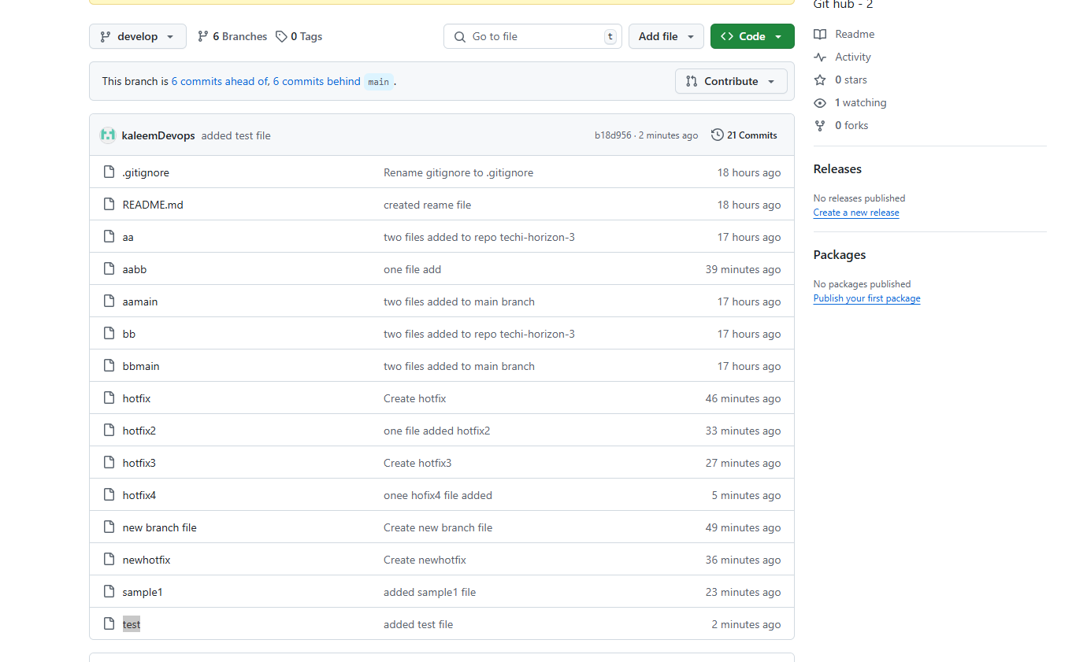

1. clone only a branch from github to local.

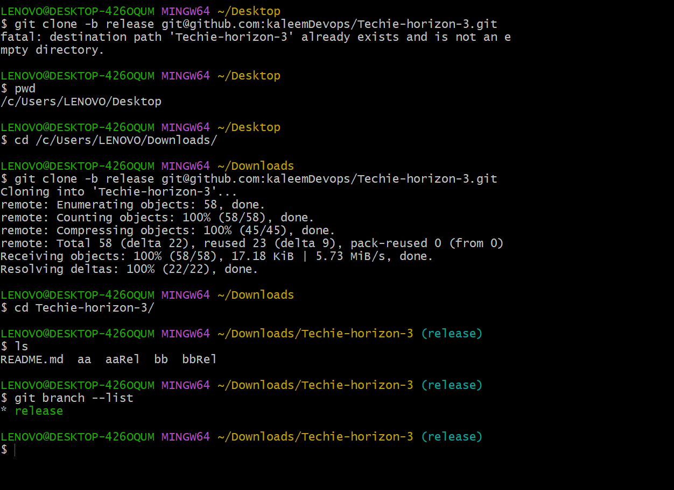

1. create a file with all passwords and make that untrackable with git.

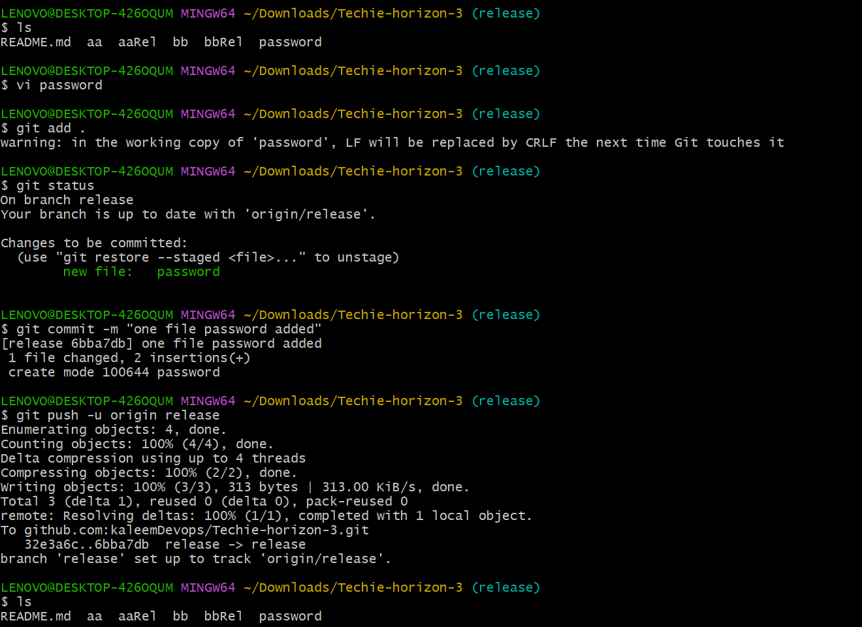

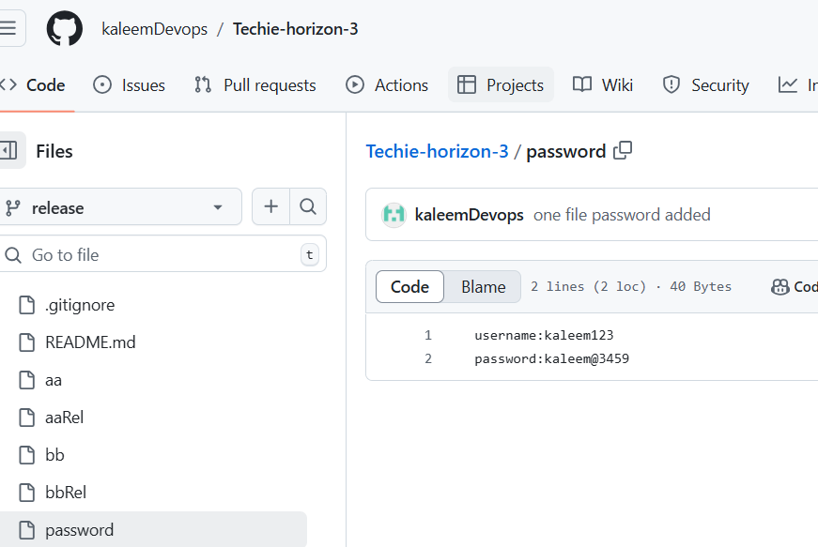

Added new file secret in gitignore

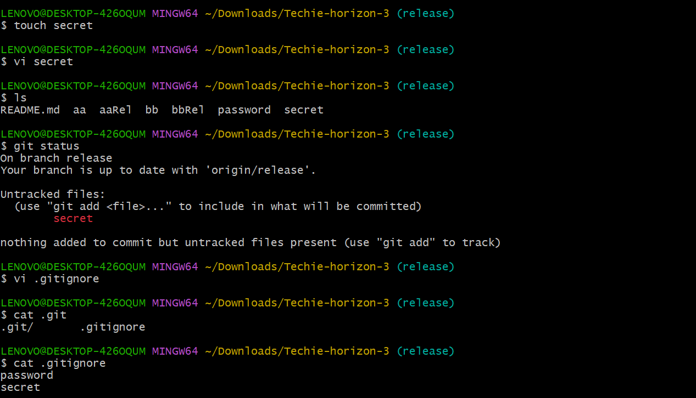

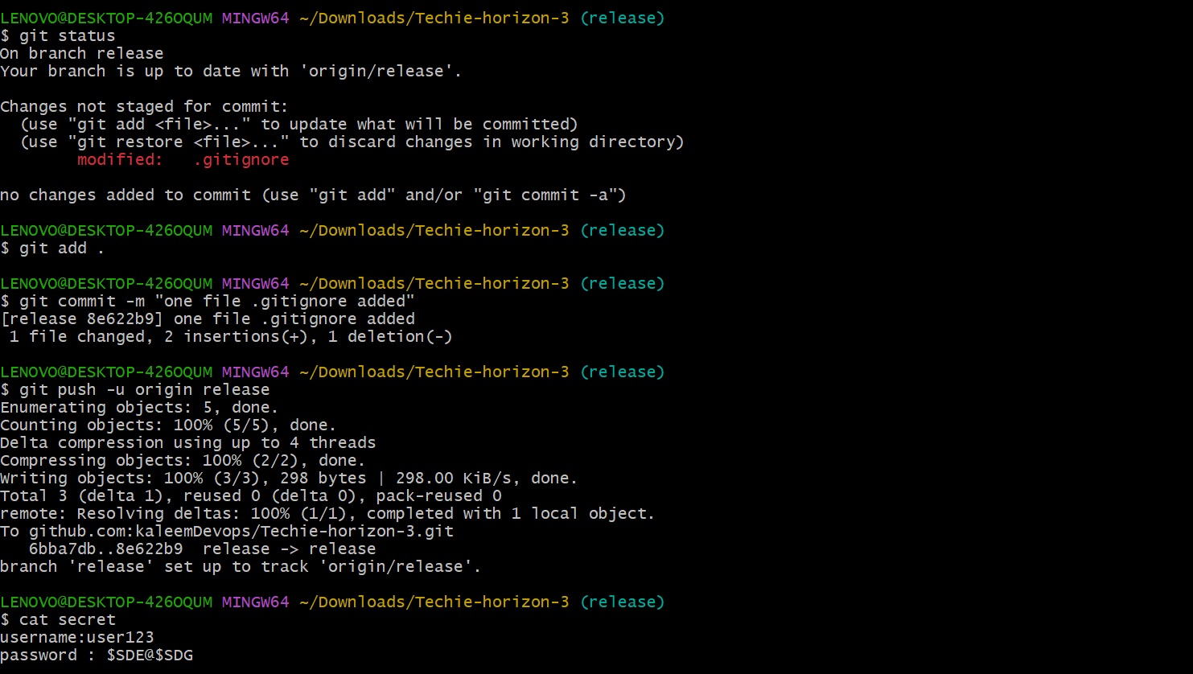

Now see secret file is hidden and shown only in gitignore

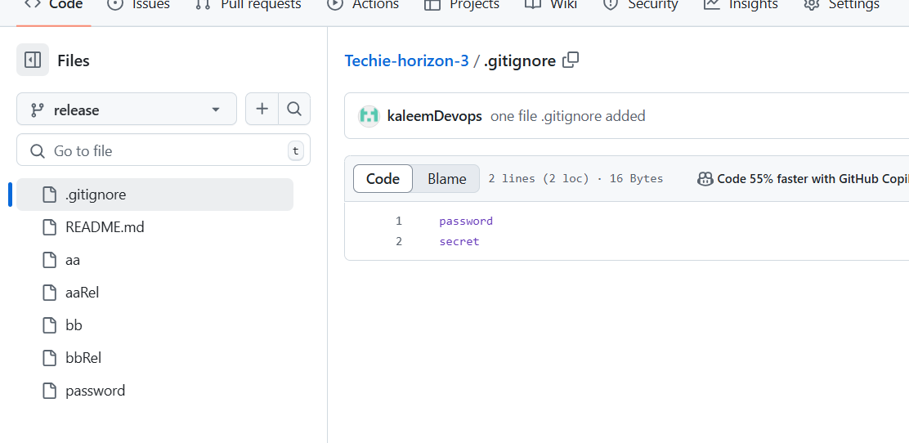

1. make a commit and make that commit reset without savings changes.

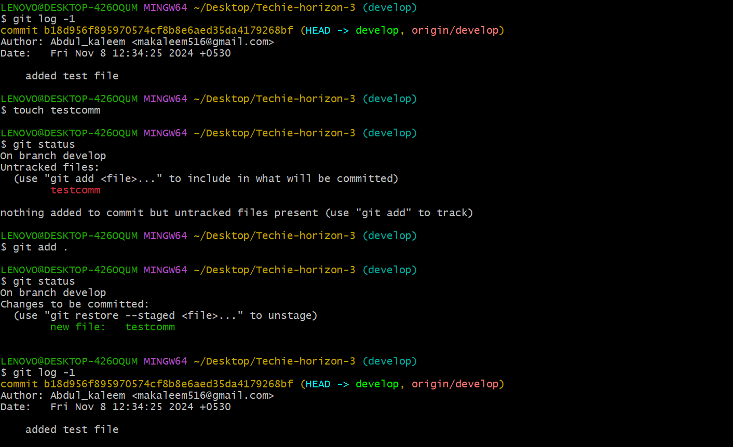

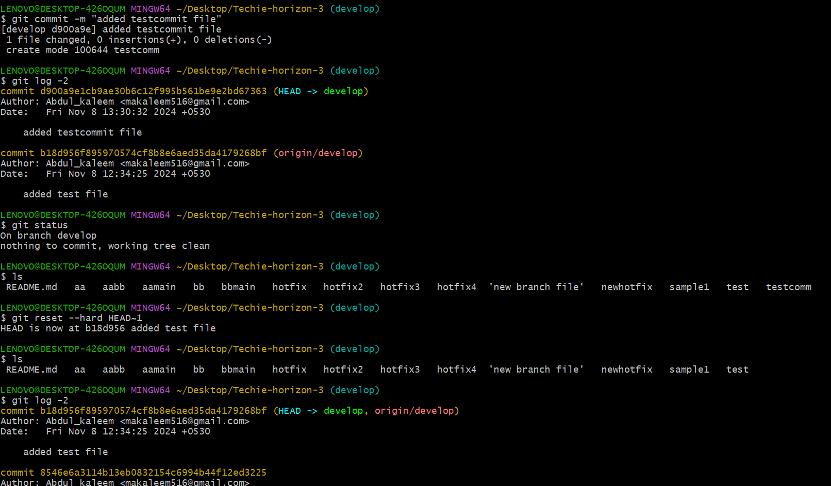

1. Revert a commited commit to the older version.

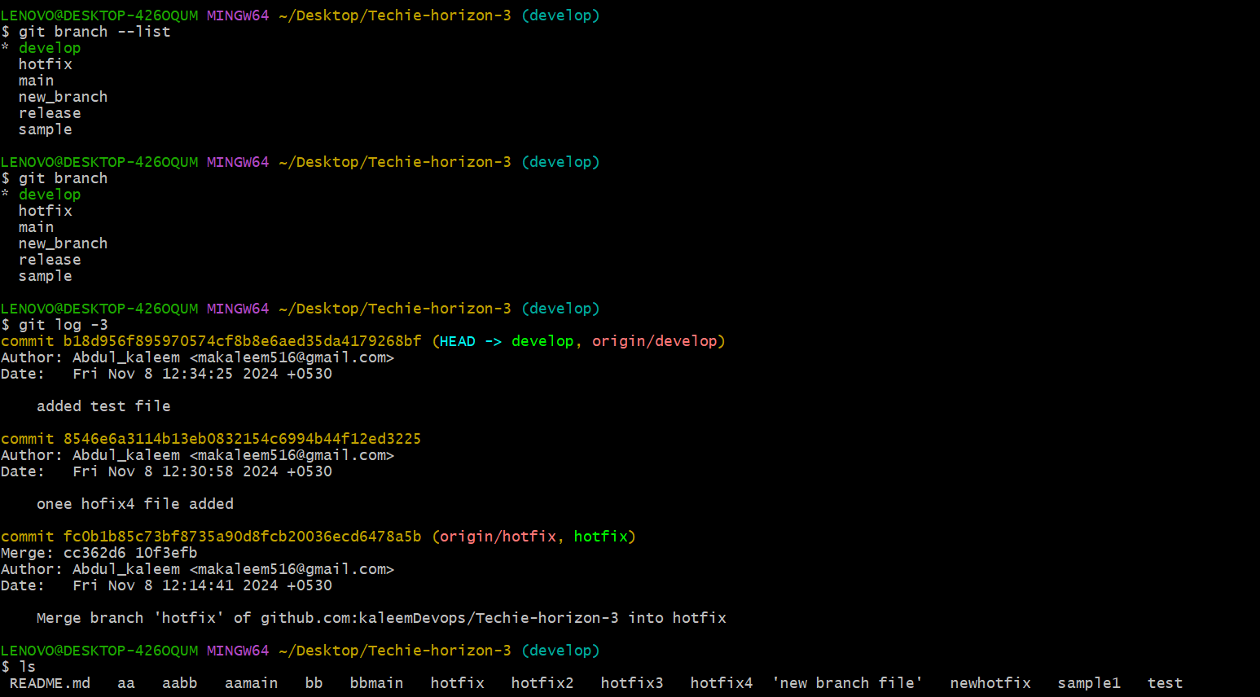

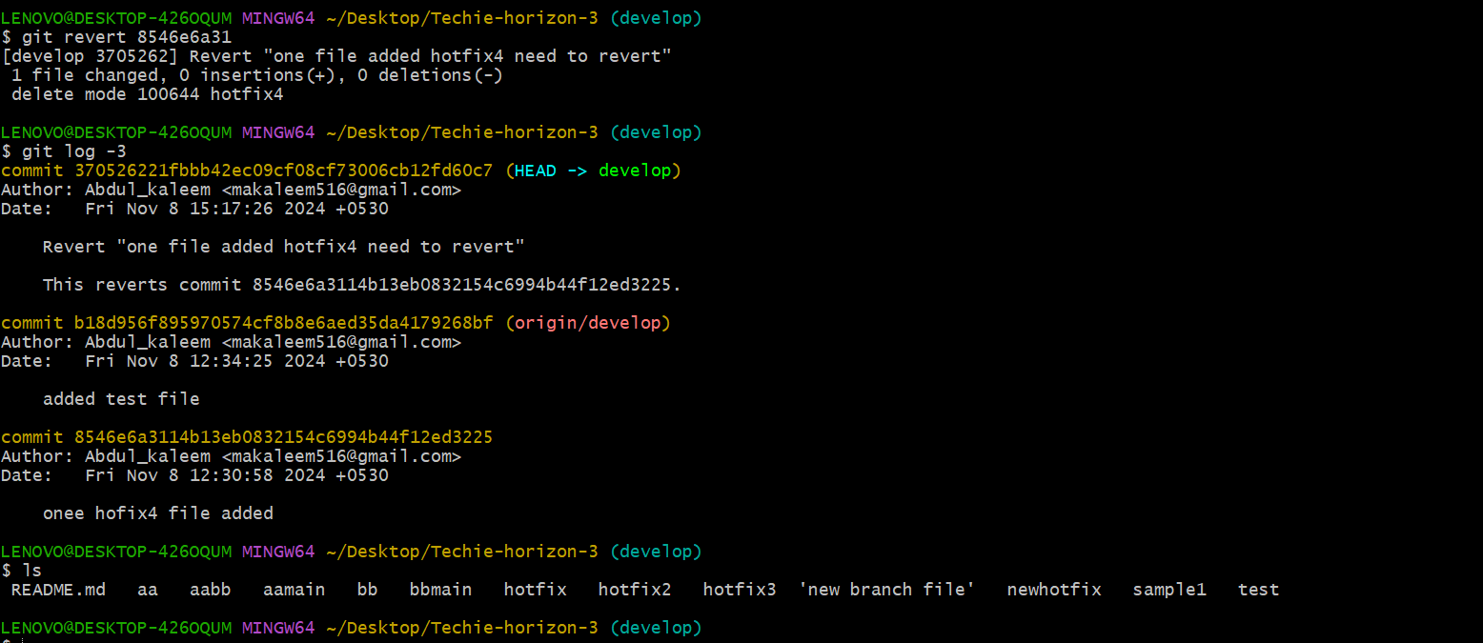

1. push a file to stash without savings the changes and work on another file.

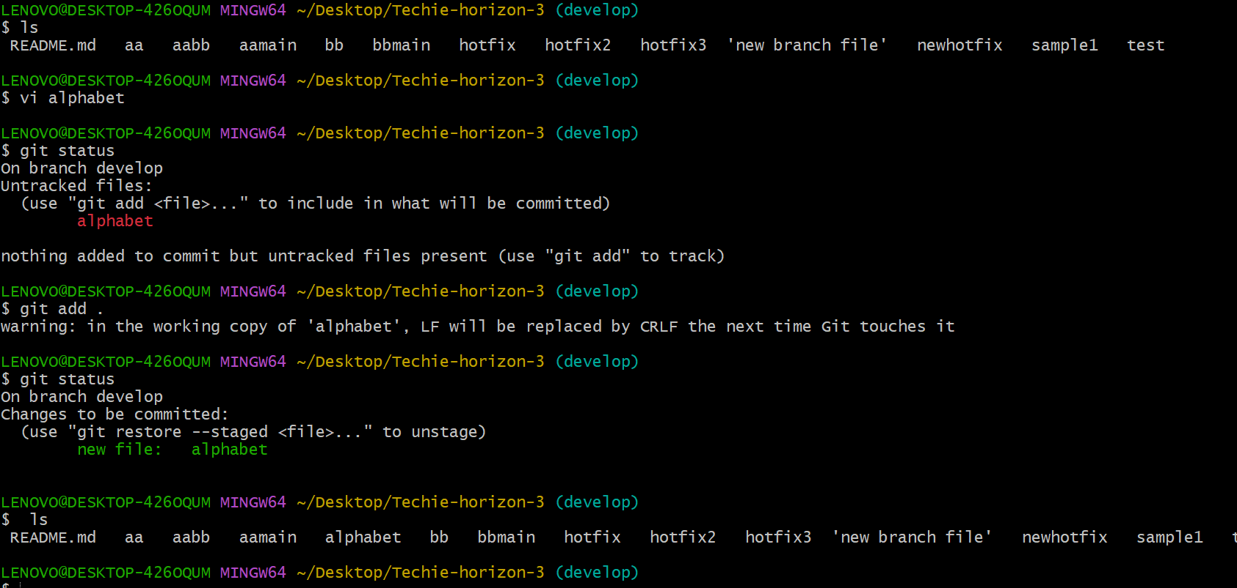

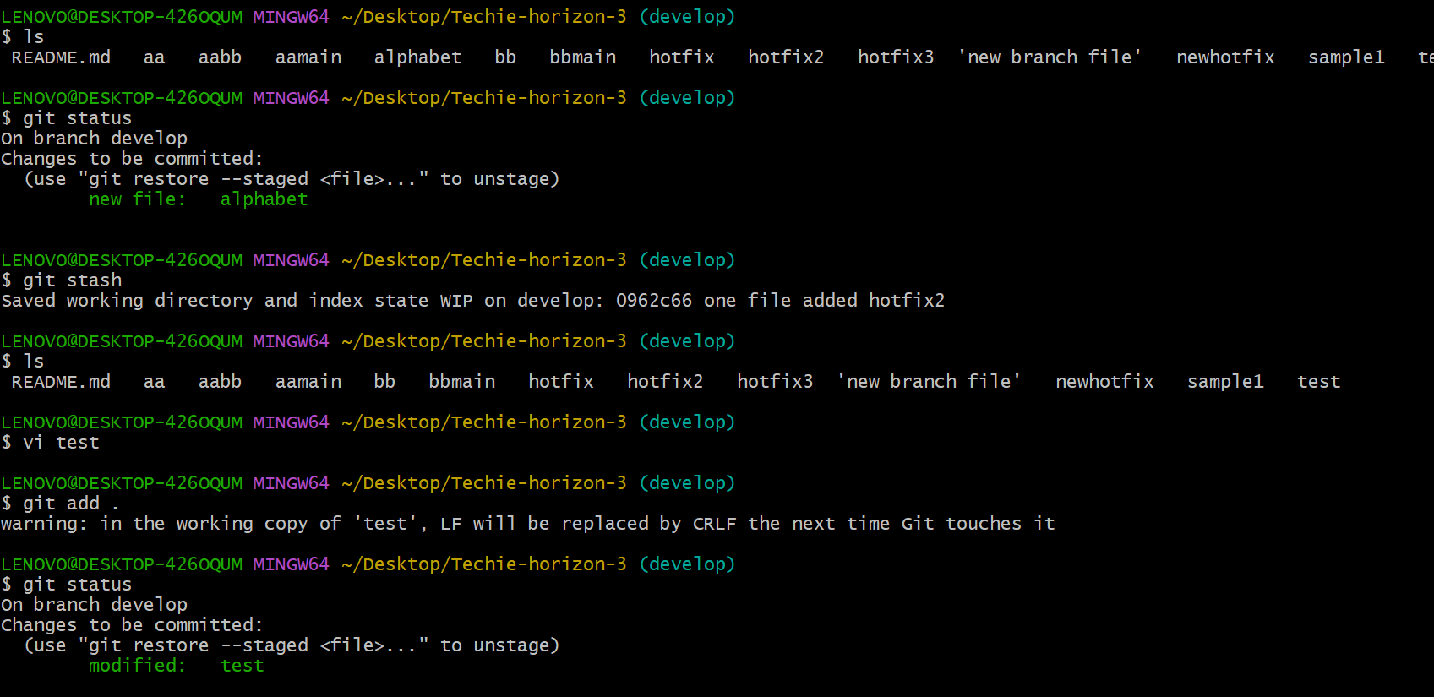

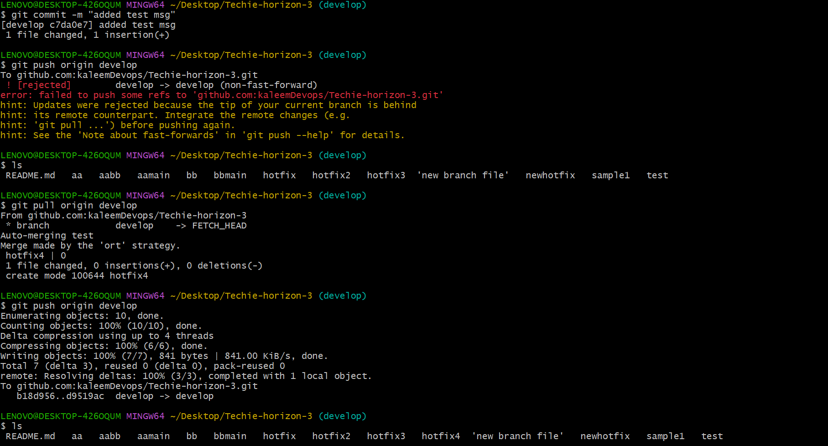

1. undo the stash file and start working on that again.

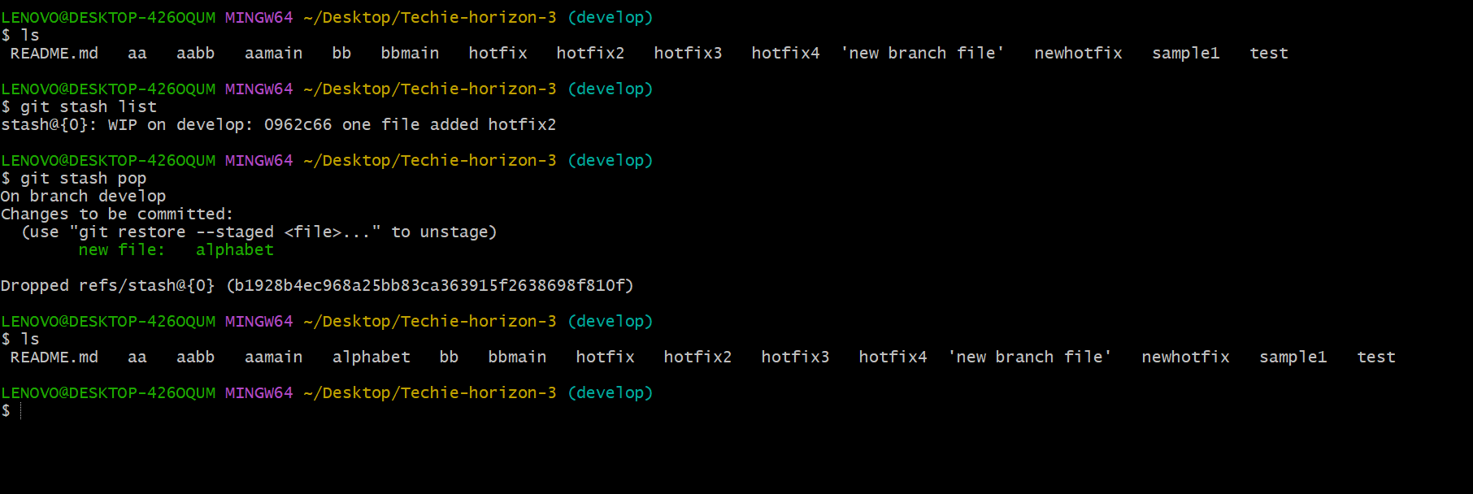

1. generate a ssh-keygen and configure into github.

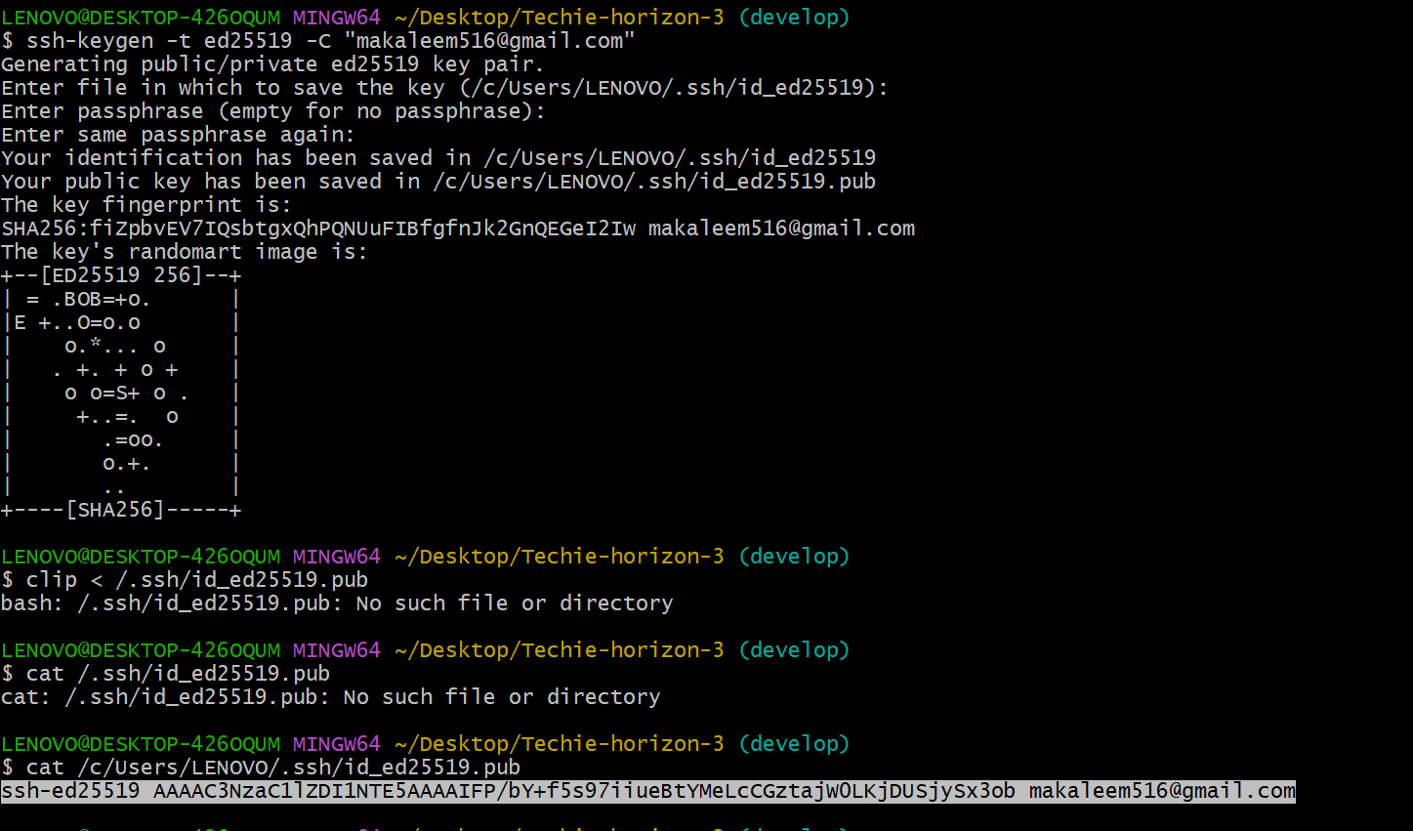

Add key in git hub

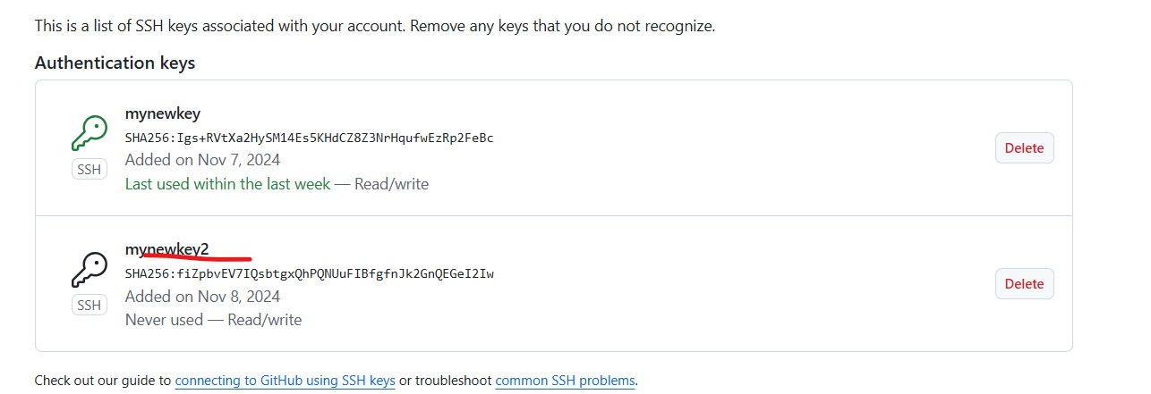

1. configure webhooks to github.
2. basic understanding of .git file.

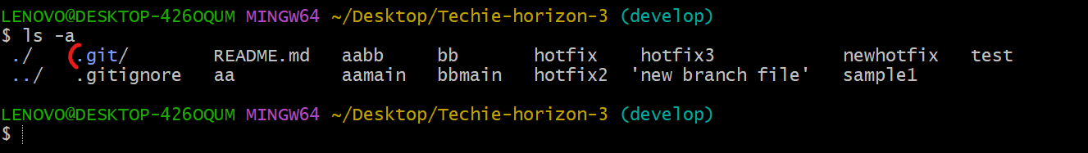

**The .git file is crucial for managing a Git repository. It is actually a directory named .git located at the root of your project. This directory contains all the metadata and object database of your Git repository. A . git folder is required to log every commit history and every other information required for your remote repository, version control, commits etc.**

1. Check all the logs of git.

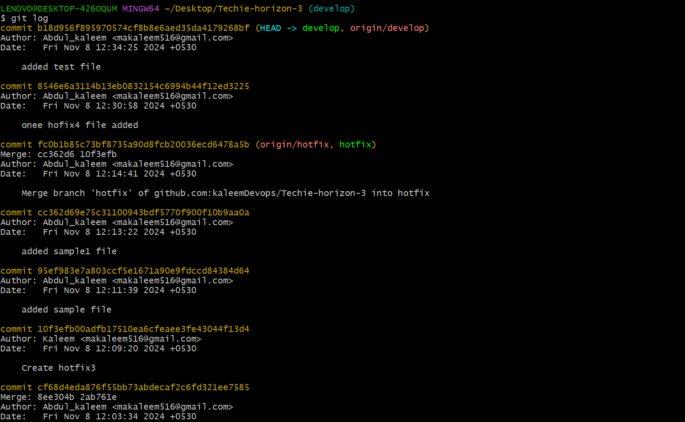

Only top 4 or 3

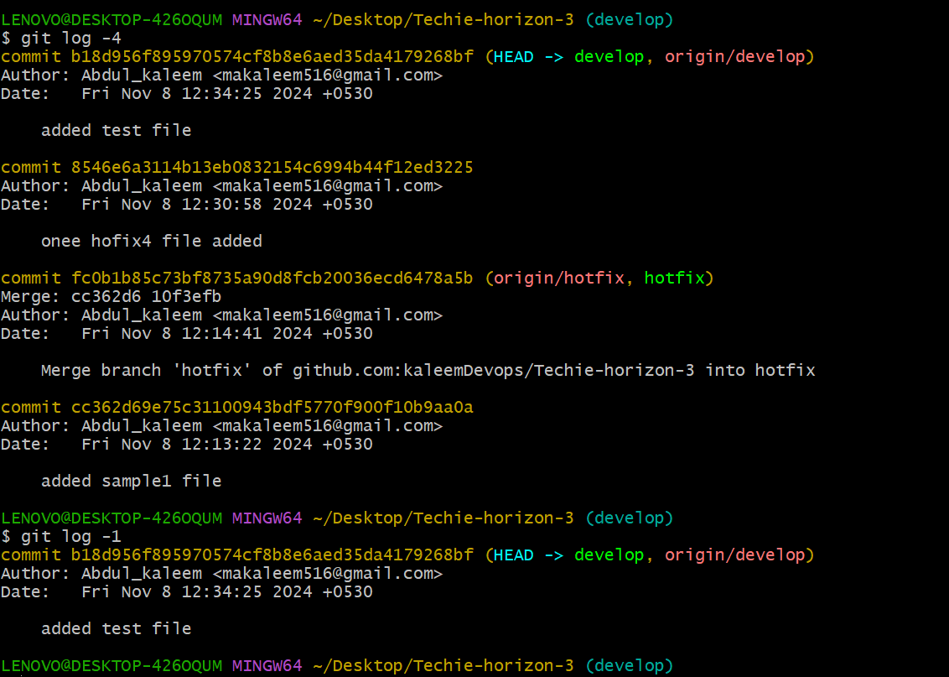

1. Rename the commit message.

* Recent commit message changed command

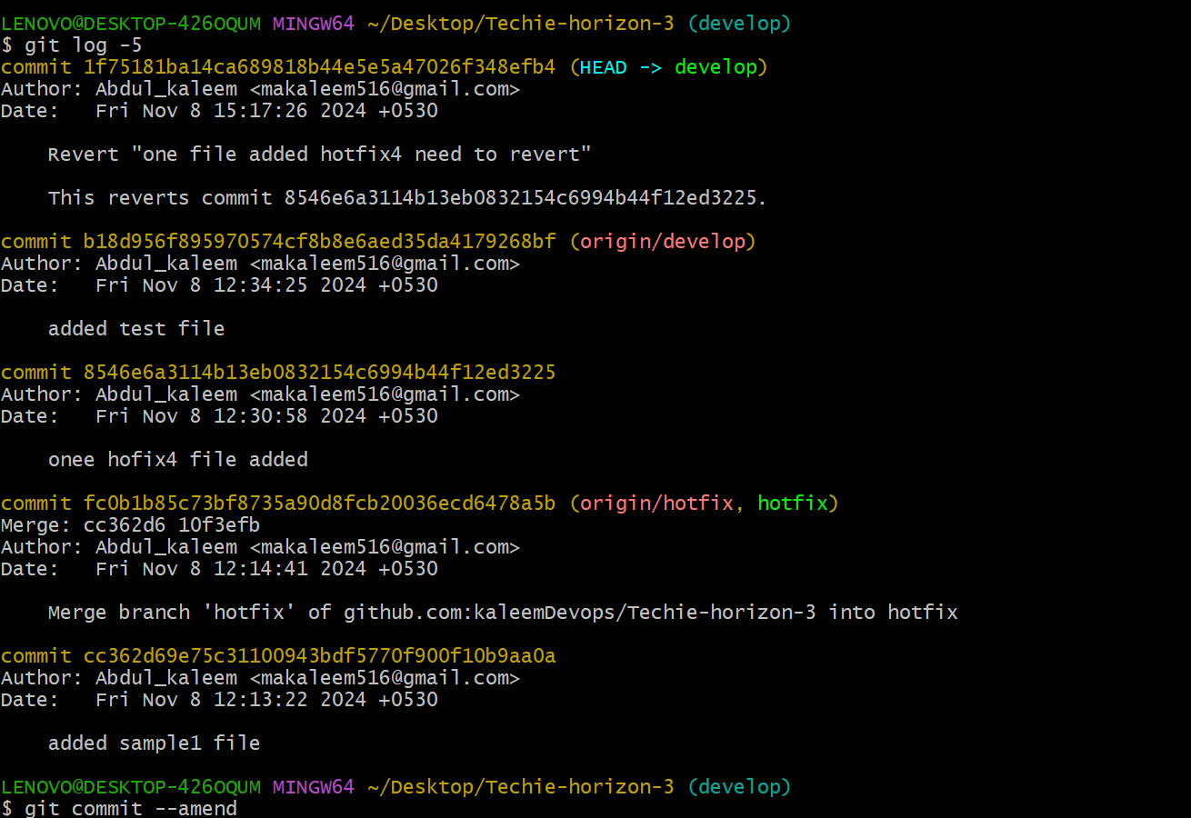

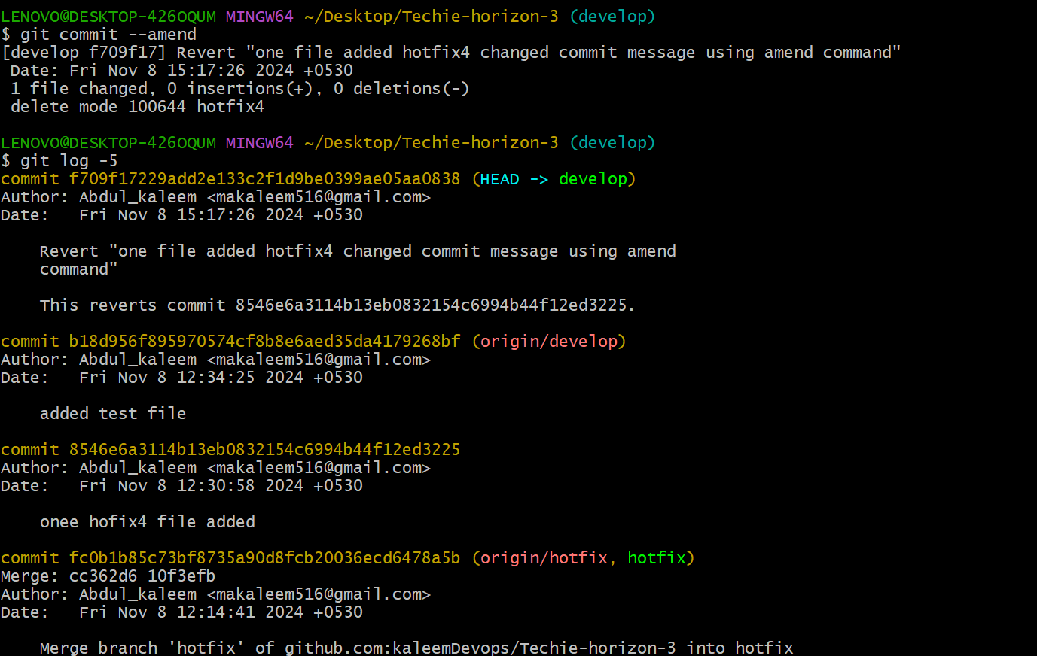

* Older commit message changed command



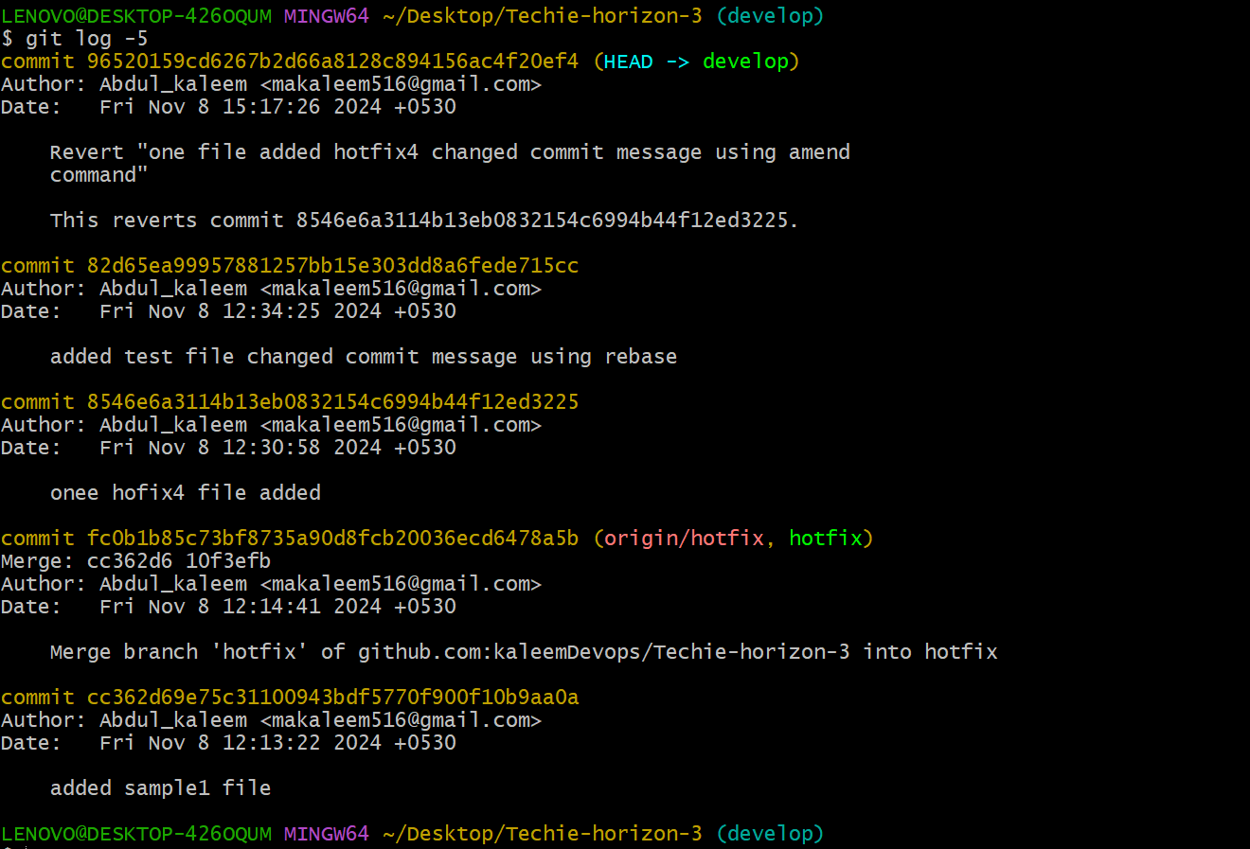

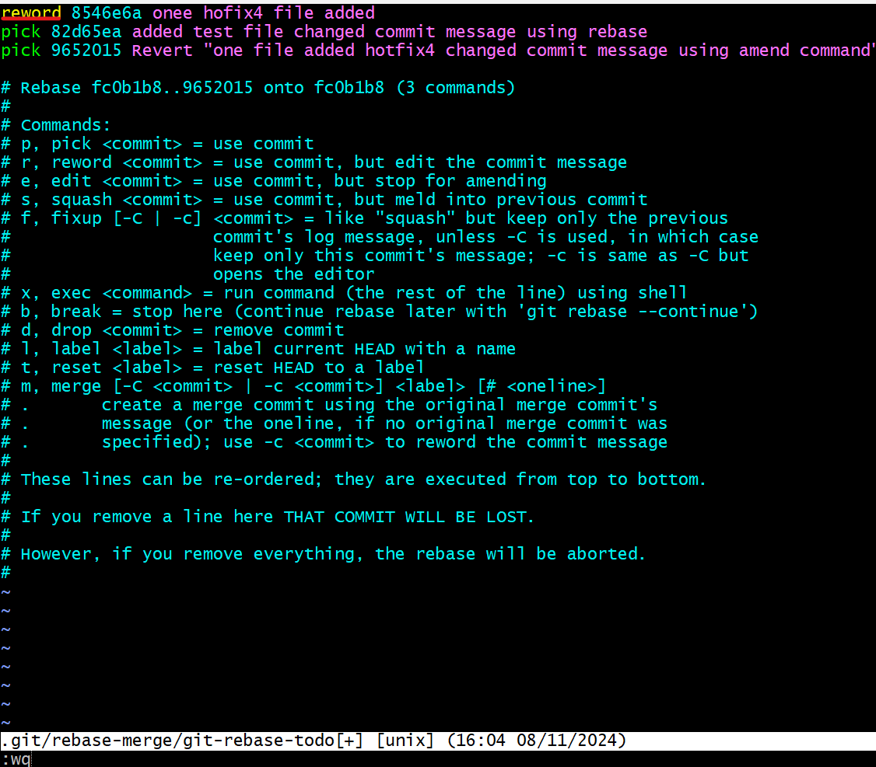

Change message the save

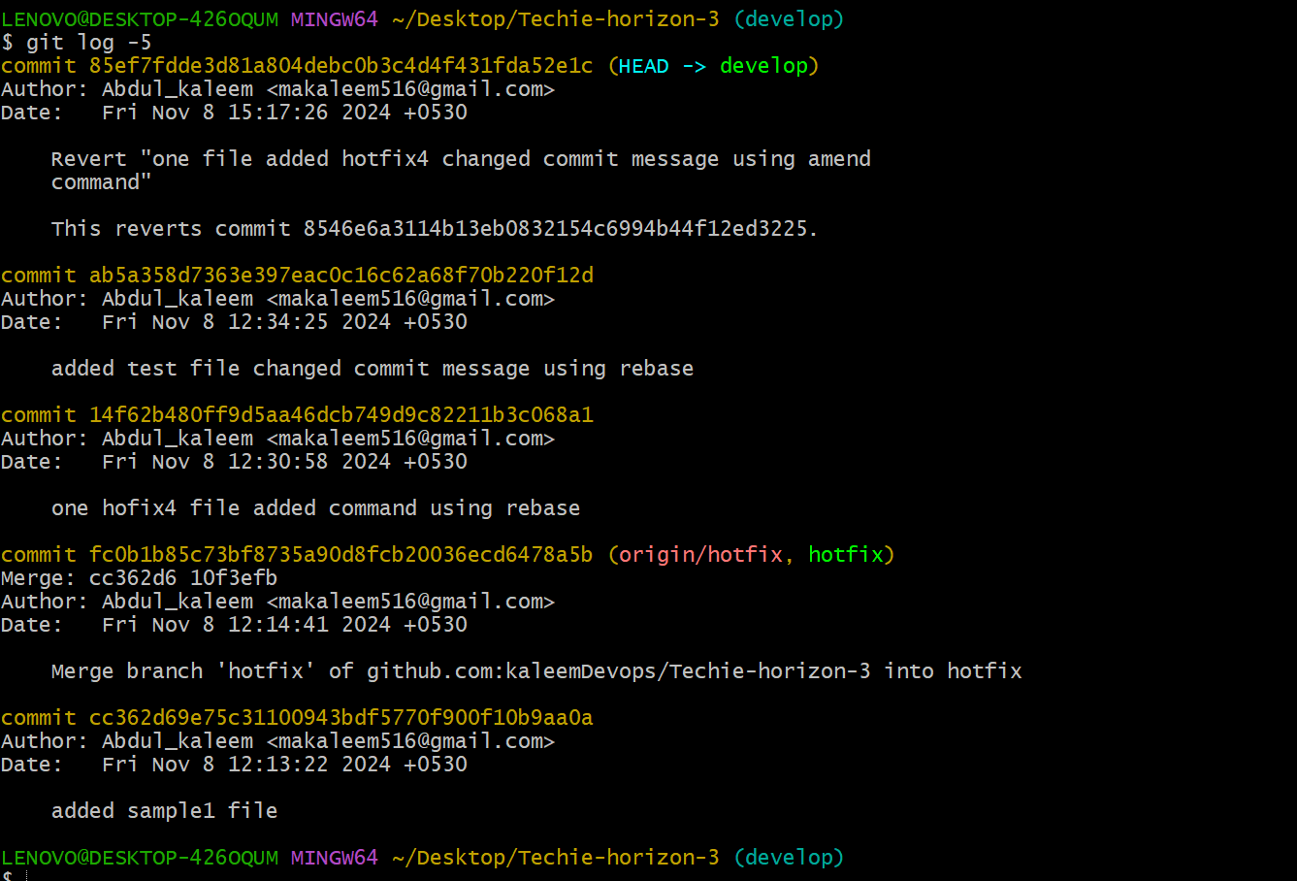

1. Merge multiple commits into single commit.

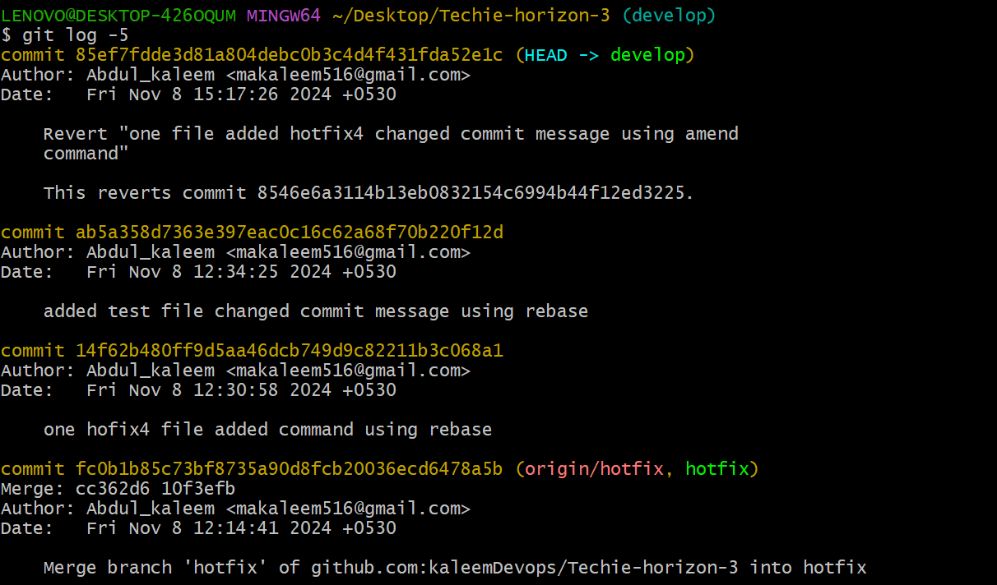

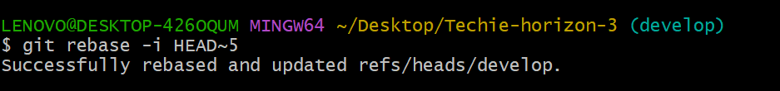

Making multiple commit to single merge

